📘 Project Report:

Image Filtering Engine
Course: Java Object-Oriented Programming (VITyarthi Project)
Student Name: Prashant Priydarshi
Reg. No. : 25BAI11147
Institution: VIT Bhopal University

1. Problem Statement & Motivation
The Problem: Graphic design software and image manipulation tools are traditionally resource-heavy, requiring massive memory overhead and complex graphical user interfaces. For users who simply need to apply standard mathematical visual filters to images, this overhead is inefficient.
Why it Matters: A lightweight, modular command-line tool allows developers and students to apply matrix convolutions natively. By building this without external dependencies, it ensures high-performance batch processing and demonstrates core Object-Oriented principles.

2. Technical Approach
- Input Source: I utilized standard uncompressed image files (e.g., JPG, PNG), processed natively through Java's built-in javax.imageio and java.awt.image libraries.
- Core Modules Selected: To move beyond simple sequential scripting, I developed distinct filter modules:
    - Grayscale (Colour averaging)
    - Sepia (Weighted mathematical colour mapping)
    - Box Blur (3x3 Grid spatial convolution)
- Algorithm & Design: I implemented the Strategy Design Pattern. While a procedural approach uses messy if/else blocks for different filters, the Strategy pattern utilizes a common ImageTransformer interface, allowing the application to dynamically swap filtering algorithms at runtime.

3. Key Decisions & Architecture
- Data Modelling: Used a custom ImageMatrix class populated with Pixel objects to ensure the algorithmic logic was separated from raw byte-level image processing.
- Interface Expansion: Used the ImageTransformer interface to standardize the input and output (taking an ImageMatrix and returning a new one). This allows for infinite scalability if new filters are added later.
- Execution Strategy: Since this is a CLI tool, I used java.util.Scanner to create an interactive terminal flow, prompting the user for input paths, filter selection, and output destinations dynamically.

4. Challenges Faced & Solutions
- The "Out of Bounds" Error: Encountered ArrayIndexOutOfBoundsException when the 3x3 Box Blur algorithm attempted to sample pixels at the very edges of the image.
    - Solution: Implemented strict spatial boundary checks (currentY >= 0 && currentY < height) to ensure the convolution matrix only sampled valid pixels.
- RGB Value Overflow Error: Experienced visual artifacting when mathematical formulas (like Sepia) pushed RGB values above the maximum byte limit of 255.
    - Solution: Utilized hard caps within the Pixel constructor to automatically clamp any computed Colour values between 0 and 255.
- File Handling Complexity: I initially tested basic file paths, but observed crashes when users typed incorrect filenames (FileNotFound).
    - Solution: Added robust exception handling (try-catch blocks) inside the ImageIOHandler to gracefully warn the user instead of terminating the program.

5. Results & Analysis
- Total Java Modules Built: 8
- Algorithmic Filters Supported: 3
Analysis: The Strategy Pattern model showed a significant improvement over standard procedural programming. The separated module approach ensures that adding a new filter (like Edge Detection) requires zero modifications to the core Main or ImageIOHandler classes.
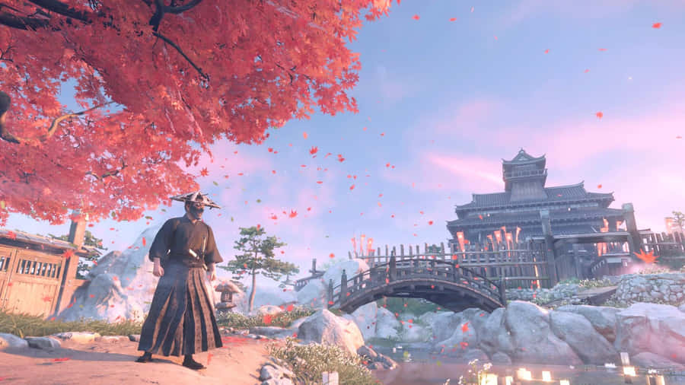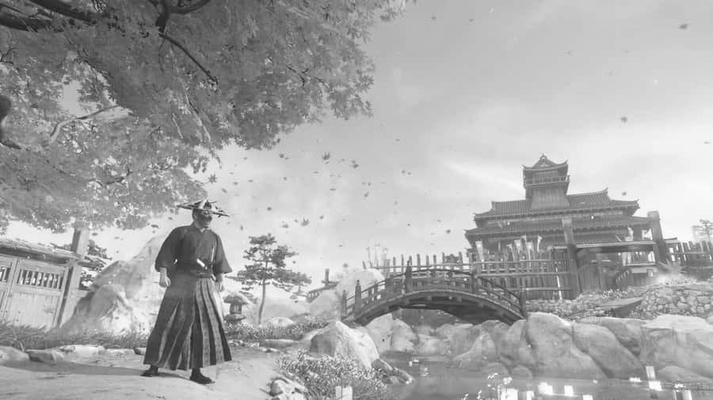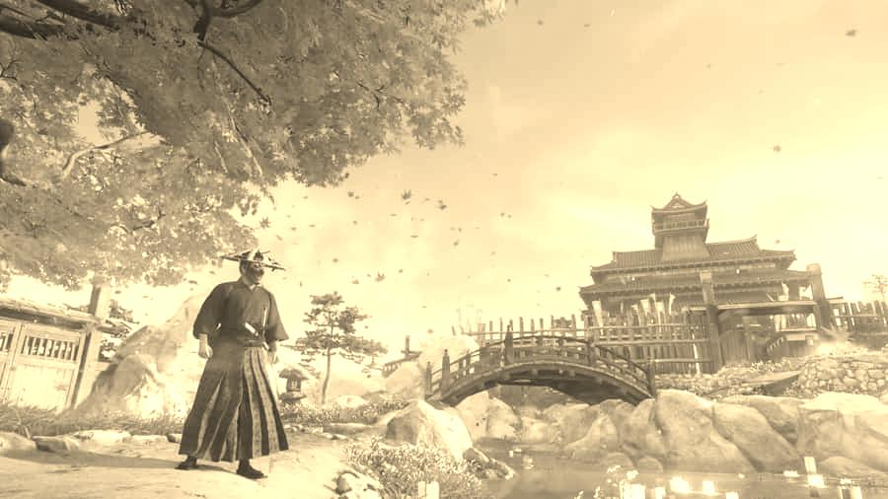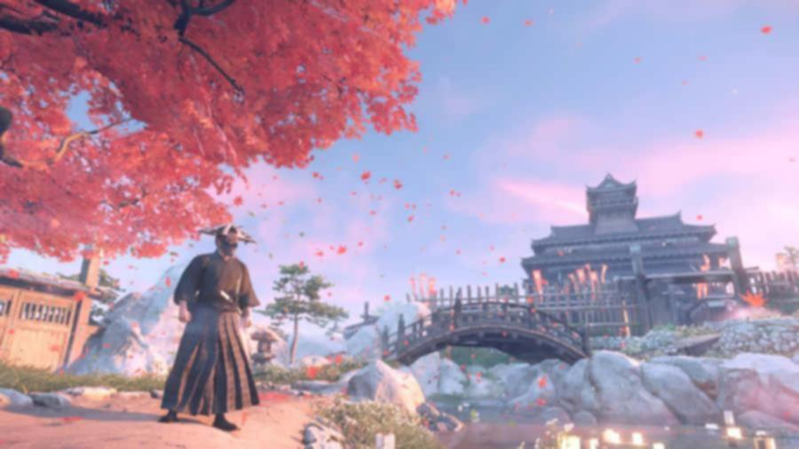

6. Conclusion & Learnings
Through this project, I learned that:
- Modularity is the engine: Applying Object-Oriented interfaces (Strategy Pattern) is essential for modern, scalable software design.
- Images are just math: Visual effects like blurring and sepia are simply localized matrix convolutions and algebraic weighting.
- Clean Code Matters: Professional error handling (try-catch) and structured CLI prompts are just as important as the algorithm itself for making a tool usable by others.

